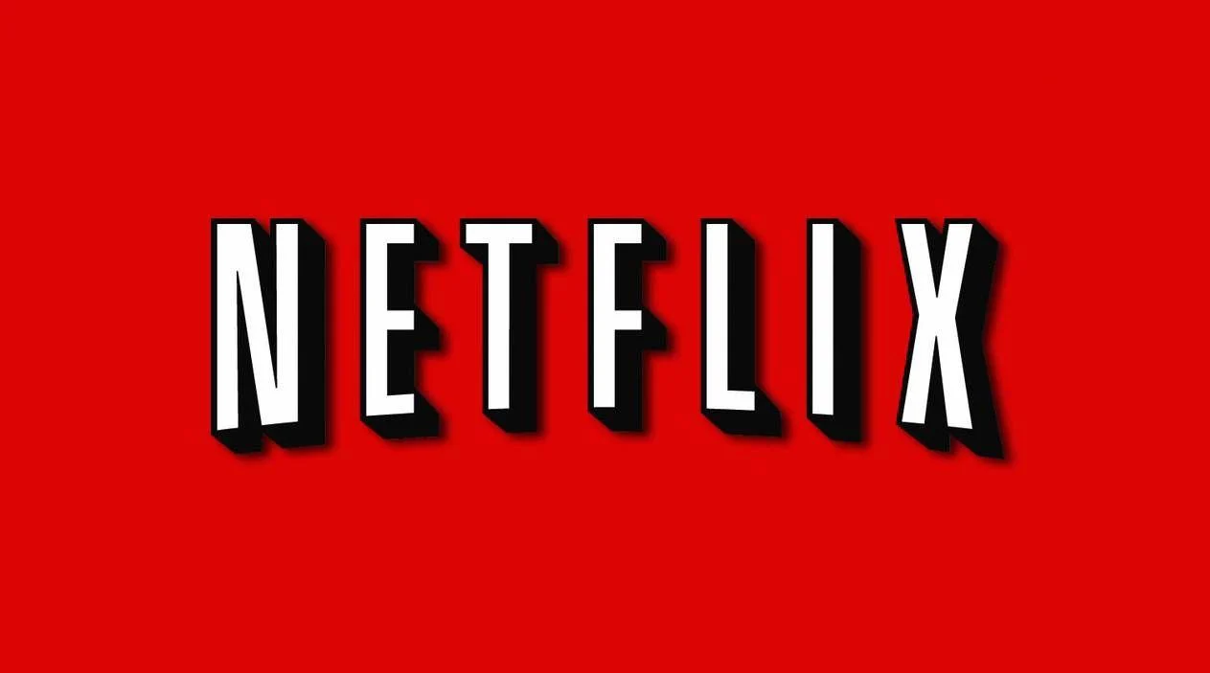

Project: Netflix

By Umang Pandya

Overview

*Netflix is one of the world's leading entertainment services with 221 million paid memberships in over 190 countries enjoying TV series, documentaries, feature films, and mobile games across a wide variety of genres and languages. Members can watch as much as they want, anytime, anywhere, on any internet-connected screen. Members can play, pause and resume watching, all without commercials or commitments.*

Backlog

*1. Sign in/Sign out*

*2. Subscription*

*3. Recommender system*

*4. Payment*

*5. Streaming*

*6. Genre/Language listing and selection*

*7. Search*

*8. Notification*

*9. Who’s watching*

History

*The history of Netflix has consistently innovated in streaming video. Over the history of Netflix, the company has maintained a content catalog that would be delivered at first via mail. When the technology infrastructure became available Netflix pioneered video technology, which revolutionized home-based video entertainment. The technical decisions that Netflix takes often serve as guides for VdoCipher’s course of action, while the long-term vision that the company has executed in its two decades has helped it standout from competition. Netflix offers a fantastic glimpse into how long-term strategy and decision-making ensured the company crested the wave of vastly increased internet connectivity in recent years.*

Technologies used in Netflix

*Front-End:*

1. *Html*
2. *CSS*
3. *Bootstrap*

*Back-End:  
 1. MongoDB*

*2. API*

*GitHub for the link.*